# **LAB#9 (ACL)**

## **Name: Saad Khan Reg np: 2020414**

* Configure IP-Addresses:

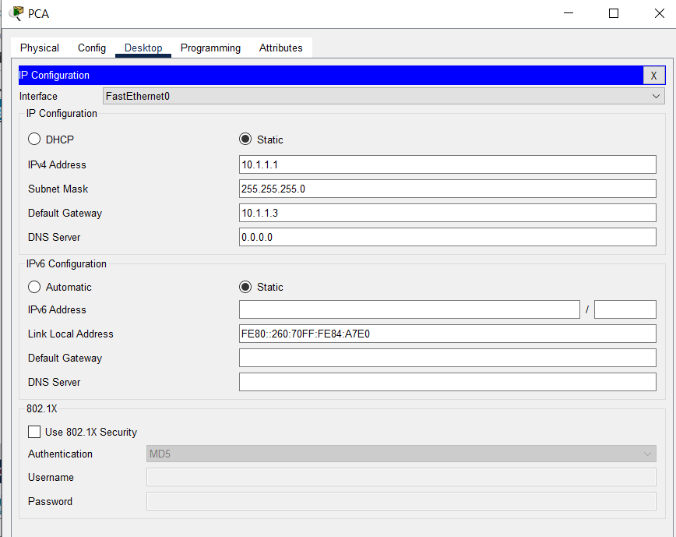PCA:

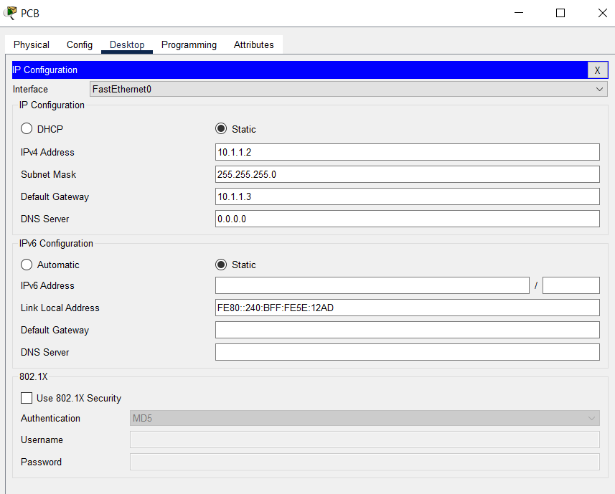PCB:

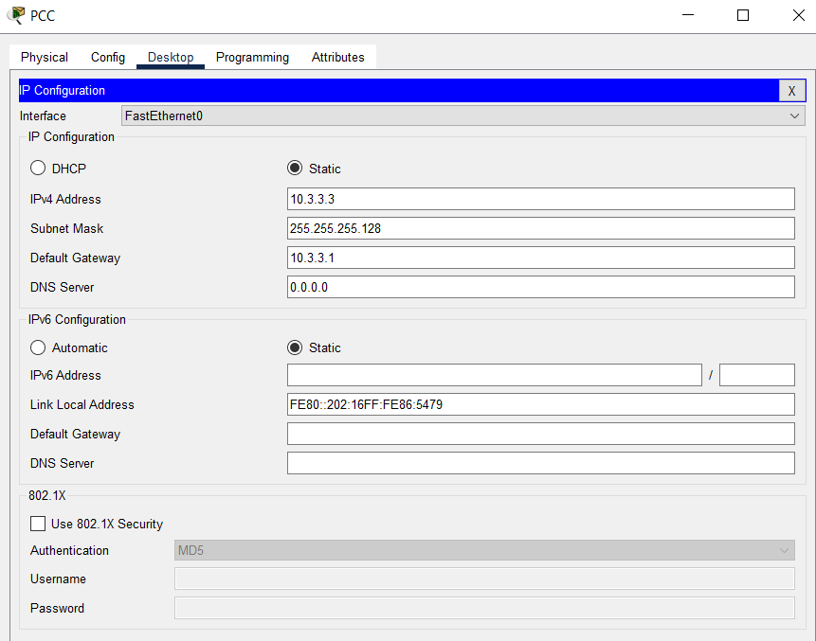PC(C)

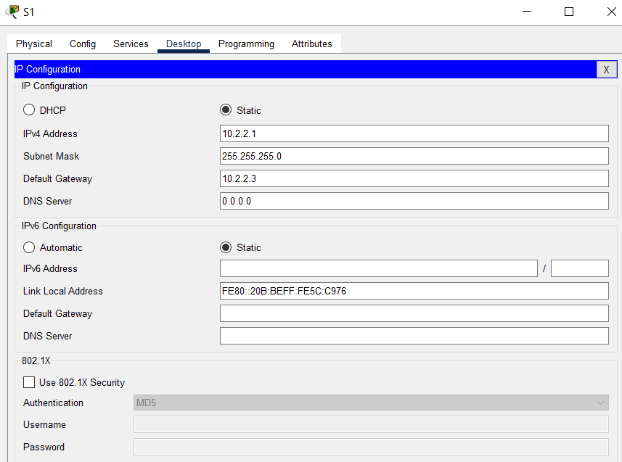S1:

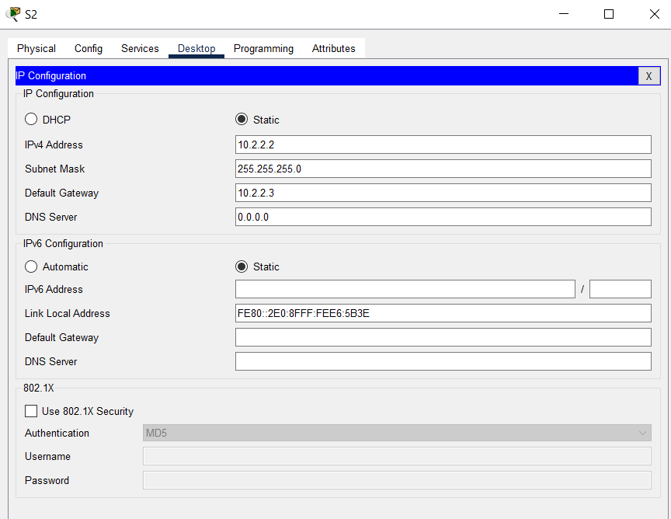S2:

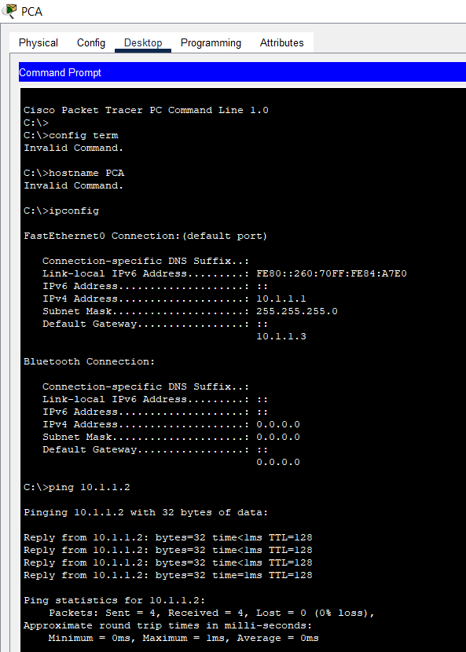**Pinging PC-A to PC-B**

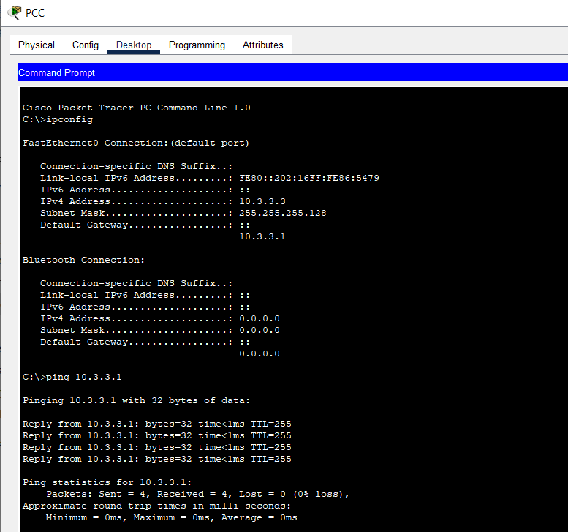**Ping PC-C to R1 :**

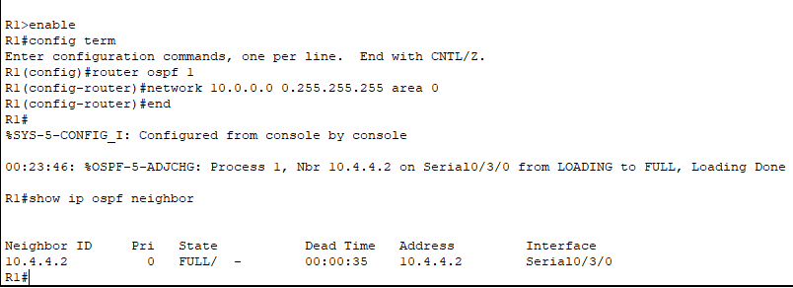**Enabling OSPF in R1:**

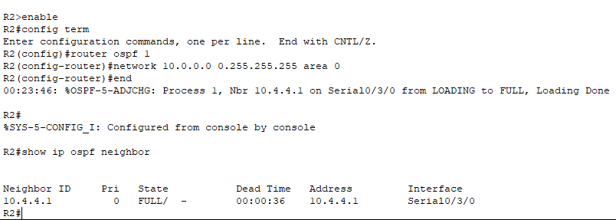**Enabling OSPF in R2:**

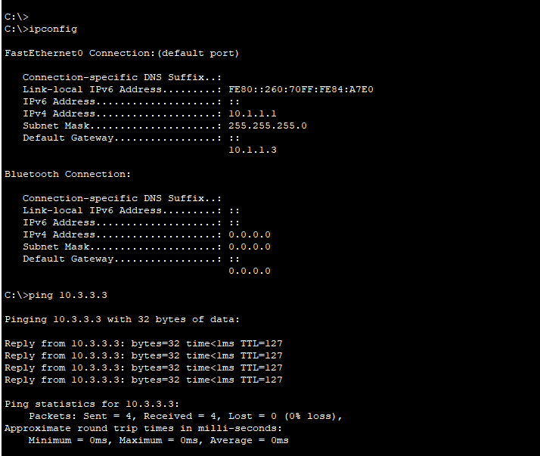**Ping from PC-A to PC-C**

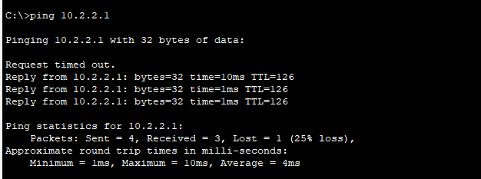**pinging PC-A to S1**:

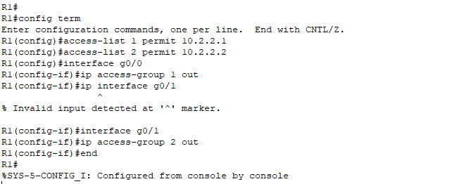**Using Out-Bound ACL on R1:**

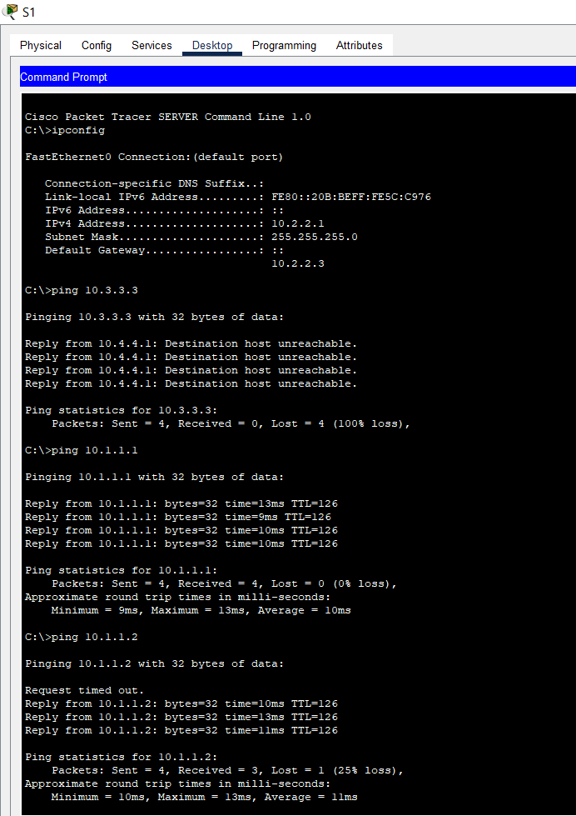**Ping from S1 to PC-A, PC-B but not PC-C**

**TOPOLOGY:**

